**Abstract Factory Design Pattern Concept**

Imagine you're in a foreign country, and you brought some of your favourite gadgets along. But here's the catch: the electrical sockets in the walls don't match the plugs of your devices. You can't charge your devices, which is a problem. The solution? You use an adapter that makes your plug compatible with the foreign socket, and voilà, your device is charging, and life is good again.

In the world of software development, particularly in object-oriented programming, we often face a similar situation. We have pieces of code (like our electronic devices) that we want to use with other parts of a program (like the wall sockets), but they just don't communicate well because their interfaces (plugs and sockets) don't match. This is where the Adapter Design Pattern comes into play. It acts like the physical adapter, making incompatible interfaces work together smoothly.

**What do you mean by “Incompatible Interfaces” ?**

Imagine you have a music player app on your phone that only supports playing music in the MP3 format, but you have a bunch of music files in a different format, let's say WAV. To play these WAV files in your MP3-only music player, you would need some sort of adapter that can convert WAV files into a format that your music player understands (MP3).

**Interfaces:**

* **Target Interface (MP3Player):** This is the interface your music player app understands.

public interface MP3Player {

void playMP3(String fileName);

}

* **Adaptee Interface (WAVPlayer):** This is the existing interface that we want to use with the target interface.

public interface WAVPlayer {

void playWAV(String fileName);

}

* **Adaptee Implementation:**

public class BasicWAVPlayer implements WAVPlayer {

public void playWAV(String fileName) {

System.out.println("Playing WAV file: " + fileName);

}

}

**Adapter:**

The adapter implements the target interface (MP3Player) and internally uses an instance of the adaptee (WAVPlayer).

public class WAVToMP3Adapter implements MP3Player {

private WAVPlayer wavPlayer;

public WAVToMP3Adapter(WAVPlayer wavPlayer) {

this.wavPlayer = wavPlayer;

}

@Override

public void playMP3(String fileName) {

System.out.println("Converting WAV to MP3: " + fileName);

// Convert WAV to MP3 logic would go here

wavPlayer.playWAV(fileName);

}

}

**Using the Adapter:**

public class MusicApp {

public static void main(String[] args) {

WAVPlayer basicWavPlayer = new BasicWAVPlayer();

MP3Player player = new WAVToMP3Adapter(basicWavPlayer);

// Now we can play WAV files on an MP3 player through the adapter

player.playMP3("file.wav");

}

}

* **MP3Player** is the target interface that our music player app can interact with.
* **WAVPlayer** is the adaptee interface, representing the WAV file format.
* **BasicWAVPlayer** is a concrete implementation of WAVPlayer.
* **WAVToMP3Adapter** is the adapter that allows WAV files to be played on a player that only supports MP3 format. It converts (or in this simplistic example, simulates the conversion of) WAV files to MP3.
* The **MusicApp** class demonstrates how you can use the WAVToMP3Adapter to play WAV files on an MP3 player.

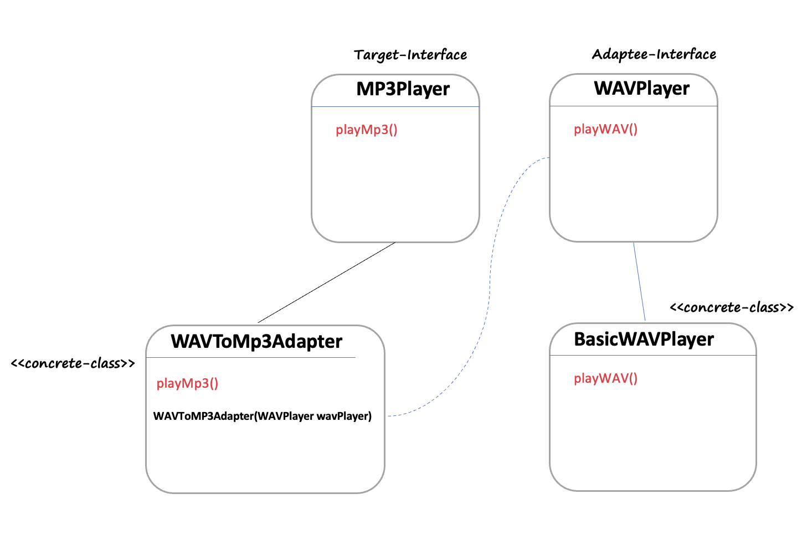

**What is Adapter Design Pattern?**

The Adapter Design Pattern, one of the structural design patterns from the famous Gang of Four design patterns, allows objects with incompatible interfaces to work together. It acts as a bridge between two incompatible interfaces. This pattern involves a single class which is responsible to join functionalities of independent or incompatible interfaces.

### When to Use the Adapter Design Pattern

1. **Interface Incompatibility:**

* Use the Adapter pattern when you want to use an existing class, and its interface does not match the one you need.
* This is common when integrating new libraries or systems.

1. **Reuse of Existing Functionality:**

* If you need to reuse existing functionality in different contexts or with different interfaces, the Adapter pattern can be an effective solution.

1. **Transitioning Systems:**

* During system migrations or when transitioning from older versions of a system to newer ones, adapters can be used to bridge the old systems with the new ones without rewriting a lot of code.

1. **Testing:**

* In testing scenarios, especially in unit testing, where you might want to mock an interface or create a stub, an adapter can be used to simulate the behaviour of the real objects.

### When Not to Use the Adapter Design Pattern

1. **System Overhaul:**

* If the system is due for a major overhaul, it might be better to refactor the system for compatibility rather than using an adapter as a patch.

1. **Simplicity Over Design Patterns:**

* In cases where a simpler solution or direct implementation is possible without adding an extra layer of abstraction, it’s better to avoid the complexity of an adapter.

1. **Performance Critical Situations:**

* If performance is a critical aspect of the system, consider the overhead that an adapter might introduce. Direct interaction without an adapter layer might be more efficient.

### Pitfalls of the Adapter Design Pattern

1. **Increased Complexity:**

* Adapters can add complexity to the code, especially when they are used extensively. This can make the system harder to understand and maintain.

1. **Indirect Communication:**

* Since adapters act as a middle layer, they introduce an additional step in communication between components. This can make debugging and tracing more challenging.

1. **Misuse of Adapters:**

* Sometimes, adapters are misused to make all classes compatible with each other, leading to a tangled system where the clear structure of the code is lost.

1. **Performance Overhead:**

* An adapter layer can introduce a slight performance overhead due to the additional method calls. While typically negligible, this can be an issue in high-performance computing scenarios.

1. **Hiding the Real Problem:**

* Adapters can sometimes be a quick fix that hides the real problem, such as a poorly designed system architecture. Over-reliance on adapters might deter necessary refactoring.